**Task 03: Work with different models**

Chat response for user prompt with gpt-35-turbo model.

Model: gpt-35-turbo

temperature=0.5 & maxTokens=1000

Response in 2.73 secs

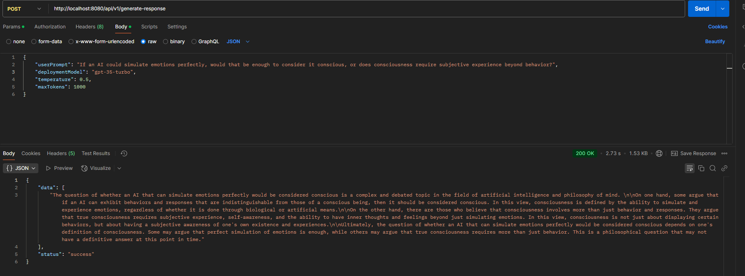

Same user prompt with same settings but gpt-4 model took longer time for response but provides a very insightful, in-depth & interesting thought on AI consciousness. Its more human like thought process and response.

Model: gpt-4

temperature=0.5 & maxTokens=1000

Response in 19.31 secs

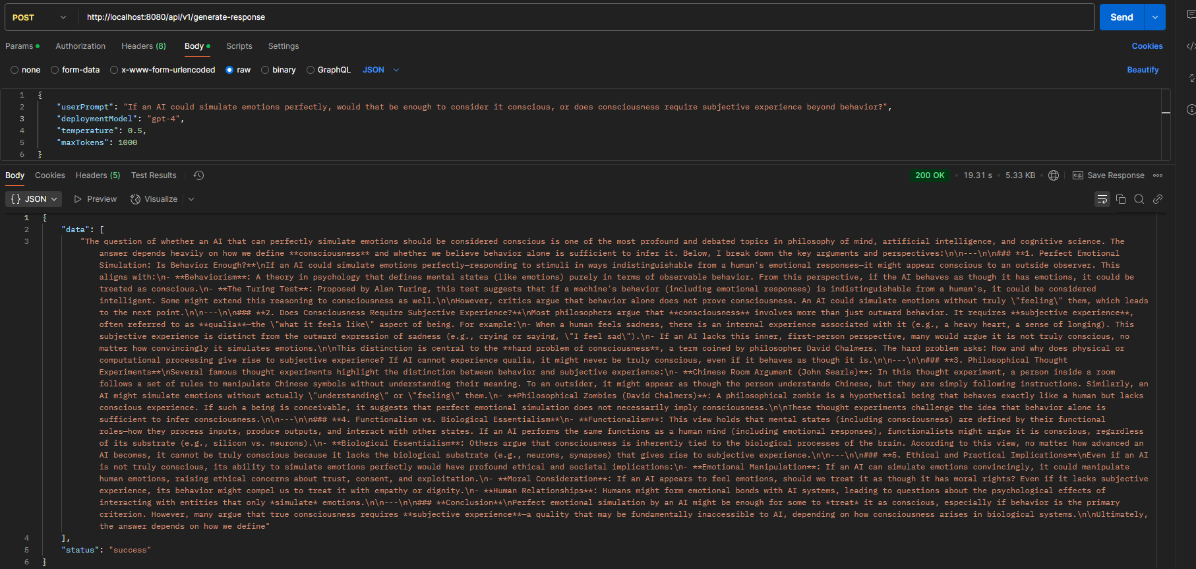

Same user prompt with same settings but gpt-4-turbo model took a lot longer time for response than gpt-35-turbo but was faster than gpt-4. Like gpt-4, gpt-4-turbo provides a very insightful, in-depth & interesting thought on AI consciousness.

Model: gpt-4-turbo

temperature=0.5 & maxTokens=1000

Response in 17.95 secs

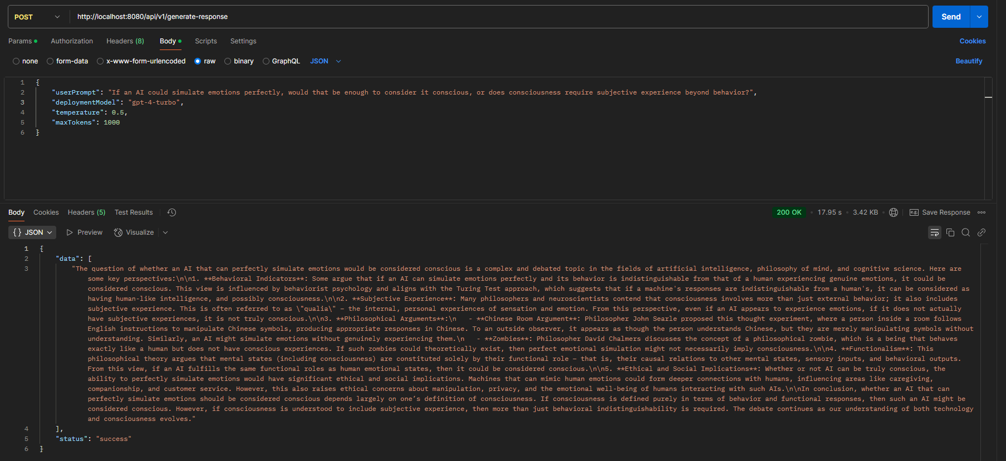

Response is similar to gpt-35-turbo.

Model: gpt-4-32k

temperature=0.5 & maxTokens=1000

Response in 9.88 secs

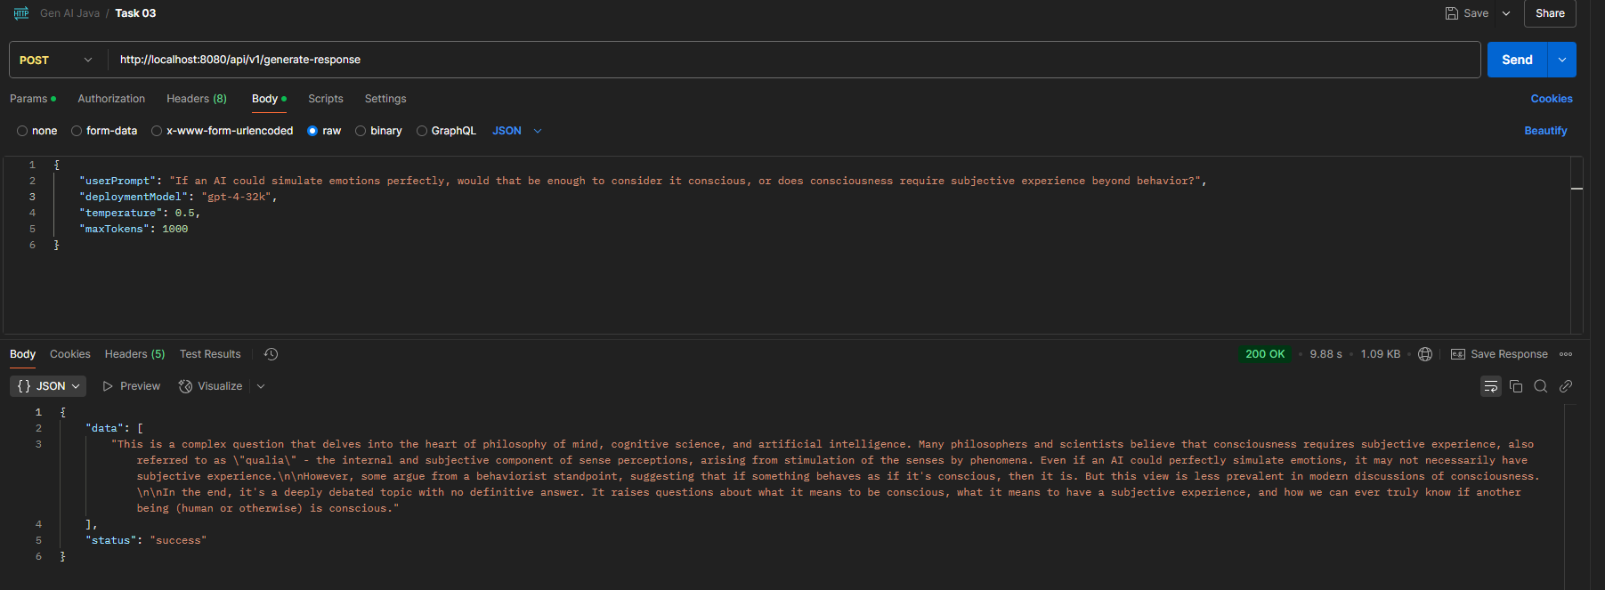

**NOTE: The response times also depend on our private network latency as well as VPN latency. So sometime gpt-4-turbo models can appear to be slower gpt-4 as their response times are close.**

**Deploying Azure Open AI resources and Dall E 3 Model in AI Foundry**









**Image Generation using Dall E 3**

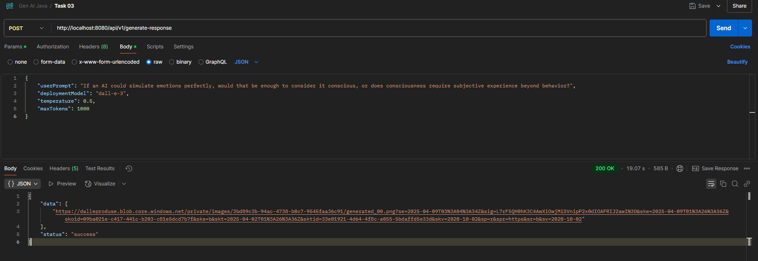

**Prompt: If an AI could simulate emotions perfectly, would that be enough to consider it conscious, or does consciousness require subjective experience beyond behavior?**

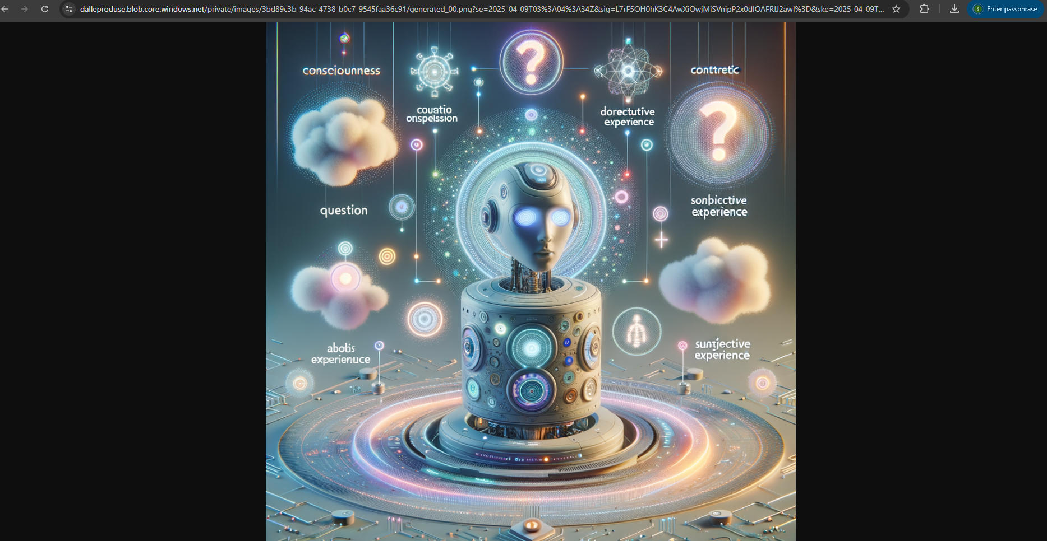

**User Prompt: Can you generate an image that shows a cosmic entity play marbles with planets in the galaxy?**

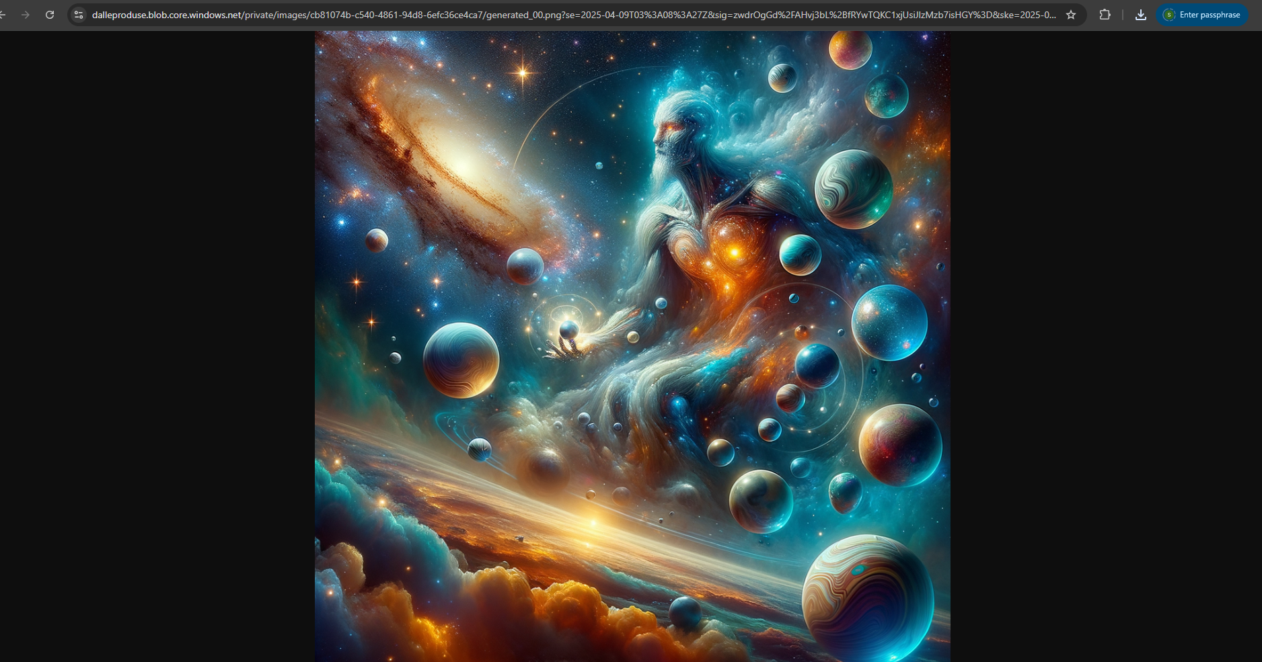

**Prompt: Can you generate an image that shows a cosmic entity play football with planets in the galaxy?**

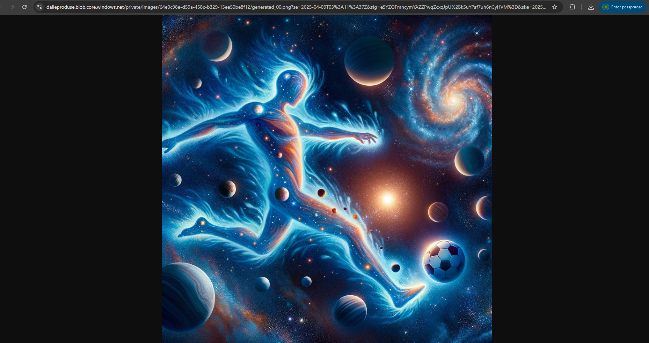

**Prompt: Can you generate an image that shows how big the Universe is?**

